CodeAlpha Task 02
Cryptocurrency Portfolio Analysis
Assets: Bitcoin (BTC), Ethereum (ETH), Solana (SOL) | Period: June 2025 to June 2026 | Currency: USD
Intern Name: Maria Imran Intern ID: CA/DF1/114610

1. Executive Summary
This report analyzes the 12-month performance and risk profile of three major cryptocurrencies: Bitcoin (BTC), Ethereum (ETH), and Solana (SOL). The analysis is based on monthly price history from June 2025 to June 2026, supported by current market data snapshots from CoinGecko/CoinMarketCap and recent market news. All three assets produced negative 12-month returns during the period. BTC declined by 41.0%, ETH declined by 32.4%, and SOL declined by 58.3%. Among the three, ETH had the highest annualized monthly volatility, while SOL had the deepest drawdown. Therefore, a conservative educational crypto allocation is suggested: 60% BTC, 30% ETH, and 10% SOL.

2. Data and Methodology
Monthly price data was used to calculate return, annualized volatility, maximum drawdown, best month, and worst month. The 12-month return was calculated as ending price divided by starting price minus one. Annualized volatility was calculated from monthly returns using the formula: monthly standard deviation x square root of 12. Maximum drawdown measures the largest fall from a previous monthly high to a later monthly low. Live market prices may change after this report date, so the Excel/Google Sheet should be refreshed before final presentation.

3. Current Market Snapshot
Asset | Live Price | Market Cap | 24h Volume | Current Context
BTC | $63,255.50 | $1.27T | $37.02B | Largest cryptocurrency by market value; high liquidity.
ETH | $1,673.79 | $202.08B | $17.02B | Second-largest crypto; smart-contract and DeFi ecosystem exposure.
SOL | $65.85 | $38.15B | $3.10B | Layer-1 network; higher-risk growth exposure in this sample.
Note: Current market figures are live-source snapshots and can change throughout the trading day.

4. Performance and Risk Analysis
Asset | Start Price | End Price | 12M Return | Ann. Volatility | Max Drawdown | Worst Month | Risk Rating
BTC | $107,135.34 | $63,156.45 | -41.0% | 32.4% | -45.4% | -17.5% | High
ETH | $2,486.46 | $1,680.79 | -32.4% | 69.7% | -61.7% | -22.2% | High
SOL | $154.74 | $64.54 | -58.3% | 46.8% | -69.1% | -28.7% | Very High
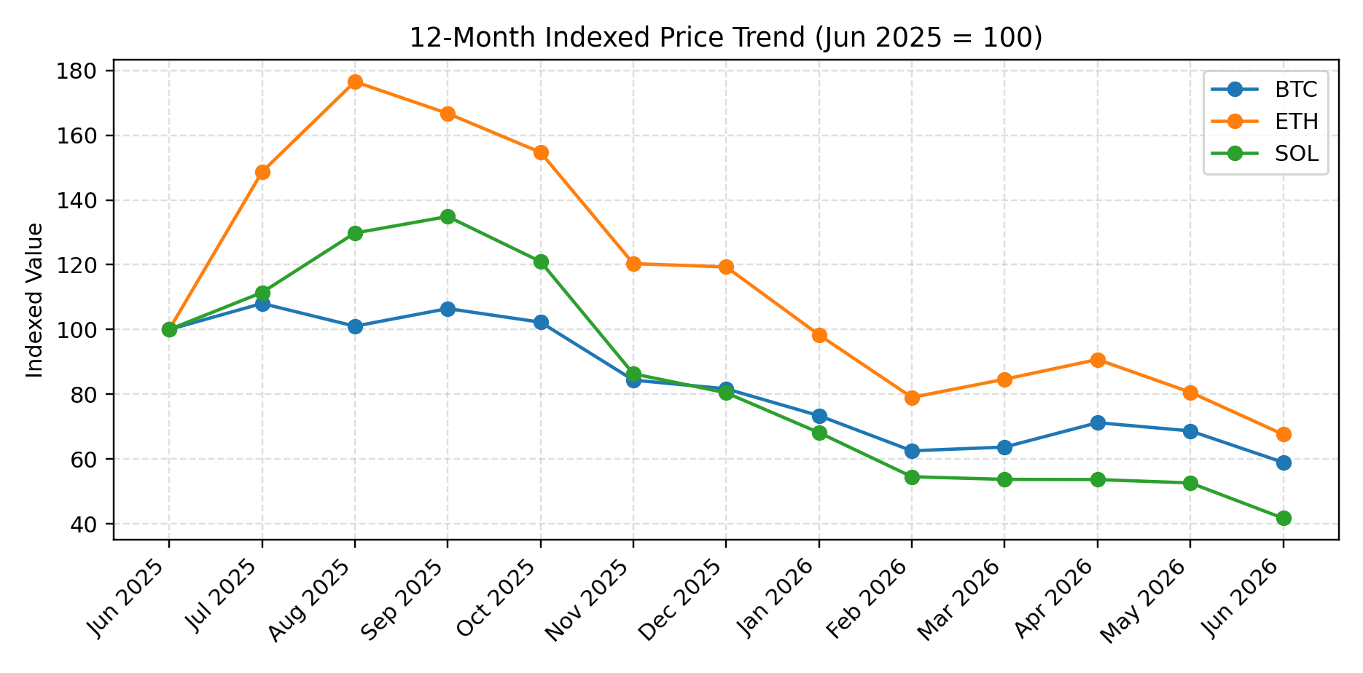

5. Asset-wise Interpretation
Bitcoin (BTC): BTC remained the core asset in the sample because it has the largest market capitalization and strongest liquidity profile. However, its 12-month return was negative, showing that even the largest cryptocurrency can suffer a major correction. BTC is suitable as the main crypto allocation in an educational portfolio, but it still carries high risk.
Ethereum (ETH): ETH showed strong upside during mid-2025 but later fell sharply. Its annualized volatility was the highest in this sample, which means price swings were larger relative to BTC and SOL over the monthly dataset. ETH remains important because of smart contracts, decentralized applications, and DeFi activity, but its price is sensitive to network demand and broader crypto risk sentiment.
Solana (SOL): SOL had the weakest 12-month performance and the largest drawdown among the three assets. The asset can provide growth exposure, but its risk is very high. For this reason, SOL should receive the smallest allocation in the recommended sample crypto portfolio.
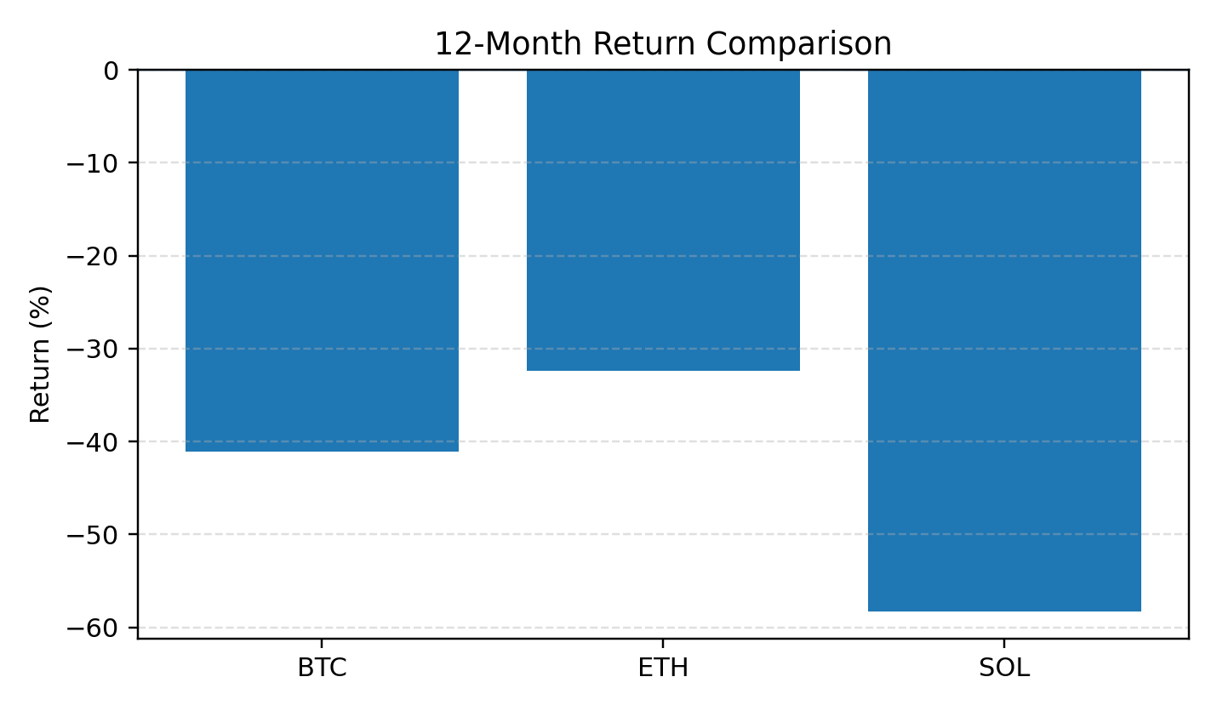
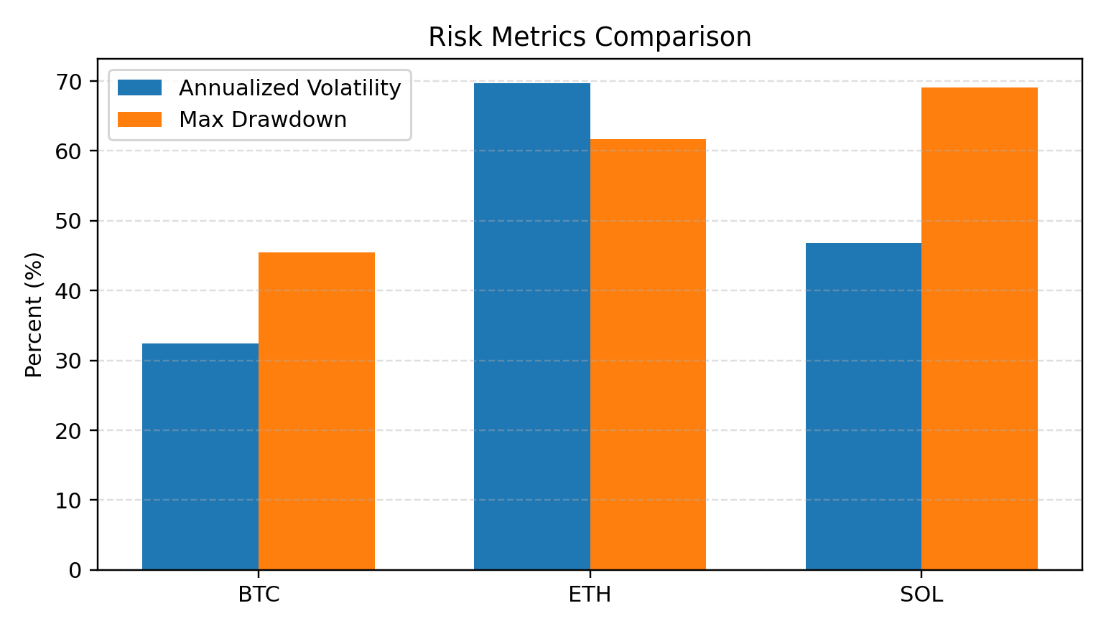

6. Portfolio Insights and Recommendations
Asset | Suggested Allocation | Reason
BTC | 60% | Core holding because of relative liquidity and market leadership.
ETH | 30% | Diversification through smart-contract and application ecosystem exposure.
SOL | 10% | Small satellite exposure because drawdown and downside risk were higher.
Risk management should be the first priority. A student investor or intern should not treat this analysis as a direct buying recommendation. Crypto assets can move sharply because of liquidity, regulation, ETF flows, macroeconomic sentiment, security issues, exchange activity, and leverage. A practical risk rule is to keep crypto as a limited part of a broader investment portfolio, diversify across assets, avoid over-leverage, and review positions regularly.

7. Conclusion
The 12-month analysis shows that BTC, ETH, and SOL all faced meaningful losses from June 2025 to June 2026. ETH had the highest annualized volatility, while SOL had the deepest drawdown and weakest total return. BTC performed better than SOL but still declined materially. The recommended sample allocation of 60% BTC, 30% ETH, and 10% SOL is therefore designed to keep the strongest/liquid asset as the core holding while limiting exposure to the highest-risk coin. This report meets the CodeAlpha Task 02 requirement by analyzing three cryptocurrencies, reviewing their 12-month performance, assessing risk, and giving portfolio-level recommendations.

References
Digrin BTC-USD monthly price history: https://www.digrin.com/stocks/detail/BTC-USD/price
Digrin ETH-USD monthly price history: https://www.digrin.com/stocks/detail/ETH-USD/price
Digrin SOL-USD monthly price history: https://www.digrin.com/stocks/detail/SOL-USD/price
CoinGecko Bitcoin market data: https://www.coingecko.com/en/coins/bitcoin
CoinGecko Ethereum market data: https://www.coingecko.com/en/coins/ethereum
CoinGecko Solana market data: https://www.coingecko.com/en/coins/solana
CoinMarketCap Solana market data: https://coinmarketcap.com/currencies/solana/
Reuters market context: https://www.reuters.com/business/finance/bitcoins-star-fades-investors-flock-lustre-ai-megacap-ipos-2026-06-05/

